PROJECT REPORT
Auto Ticket Classification using Flow Designer
(ServiceNow – School IT Helpdesk)

Valluvar College of Science and Management (Autonomous), Karur
III BCA, Department of Computer Science
githb link:https://github.com/rohini-r-2006/Auto-ticket-Classification-using-flow-designer-.git

Team ID | SWTID-2026-9175
Team Size | 5
Team Leader | MADHURASUBASHINI C
Team Member | MUNEESWARI M
Team Member | PAPPATHY S
Team Member | ROHINI R
Team Member | SANTHIYA K

Table of Contents
1. Introduction
2. Ideation Phase
3. Requirement Analysis
4. Project Design
5. Project Planning & Scheduling
6. Functional and Performance Testing
7. Results
8. Advantages & Disadvantages
9. Conclusion
10. Future Scope
11. Appendix

1. Introduction

1.1 Project Overview
The school IT helpdesk receives many incident requests every day from students and teachers, such as Wi-Fi issues, projector failures, password problems and slow computers. IT staff currently review each request manually and assign a category, which is time-consuming and inefficient.
This project automates ticket classification using ServiceNow Flow Designer. When a ticket is created, the flow checks keywords in the Short Description, fills the Category and Subcategory automatically and sends a confirmation email to the caller. The whole solution is built without code.

1.2 Purpose
- Automatically classify incidents at the time of creation.
- Reduce manual effort for IT agents.
- Improve ticket routing efficiency.
- Implement a no-code, easily maintainable solution.

2. Ideation Phase

2.1 Problem Statement
 | I am | Trying to | But | Because | Which makes me feel
PS-1 | a student / teacher | report an IT issue and get it fixed quickly | my ticket waits for IT staff to categorize it manually | classification is manual, with no instant acknowledgement | frustrated and unsure my request was received
PS-2 | an IT helpdesk agent | classify and route many daily tickets | I read every ticket and select Category and Subcategory by hand | tickets are free text and manual selection is error-prone | overloaded and worried about errors

2.2 Empathy Map Canvas
 | Student / Teacher | IT Helpdesk Agent
Says | “My Wi-Fi / projector is not working.” “Did anyone get my request?” | “Too many tickets today.”
Thinks | “Will this be fixed before my class?” | “This manual work is repetitive.”
Does | Creates a ticket and waits or follows up in person | Reads each ticket and sets Category and Subcategory
Feels | Frustrated, uncertain | Overloaded, stressed
Pains | No confirmation, slow response | Manual review, human errors, not scalable
Gains | Instant email confirmation, quick resolution | Automatic classification, less manual effort

2.3 Brainstorming
Ideas were grouped into Automation, Data structure, Communication and Future ideas, then prioritized by impact and effort.
Idea | Impact | Effort | Priority
Keyword-based auto classification using Flow Designer | High | Low | Selected
Auto email confirmation to the caller | High | Low | Selected
Dependent Category → Subcategory choices | Medium | Low | Selected
Auto-assign tickets to groups / agents | High | Medium | Future scope
SLA tracking and dashboards | Medium | Medium | Future scope
Predictive intelligence / chatbot | High | High | Future scope

3. Requirement Analysis

3.1 Customer Journey Map
Stage | Steps | Opportunity
Entice | Faces an IT problem (Wi-Fi, projector, password, slow computer) | Display clear instructions
Enter | Opens the Incident WorkFlow form | Reduce form fields
Engage | Enters Caller and Short Description and saves | Add more keywords to the flow
Exit | Flow classifies the ticket; email is sent | Include ticket number in email
Extend | IT staff resolve the ticket | Add auto-assignment and SLA tracking

3.2 Solution Requirements
Functional requirements:
- FR-1 Ticket creation with Caller and Short Description; auto-numbered ticket ID.
- FR-2 Auto classification: Wi-Fi / Network → Network / Wi-Fi; Projector → Hardware / Projector; Forgot password → Access / Forgot Password; Slow computer → Performance / Slow Computer.
- FR-3 Category–Subcategory dependency using dependent choice fields.
- FR-4 Automatic email notification to the caller on ticket creation.
- FR-5 Ticket data stored in the custom table Incident WorkFlow, with role-based access.
Non-functional requirements: usability, security (ACL on the custom table), reliability, performance (classification at ticket creation), availability (cloud-hosted instance) and scalability (new keywords added as extra Else If branches).

3.3 Data Flow Diagram
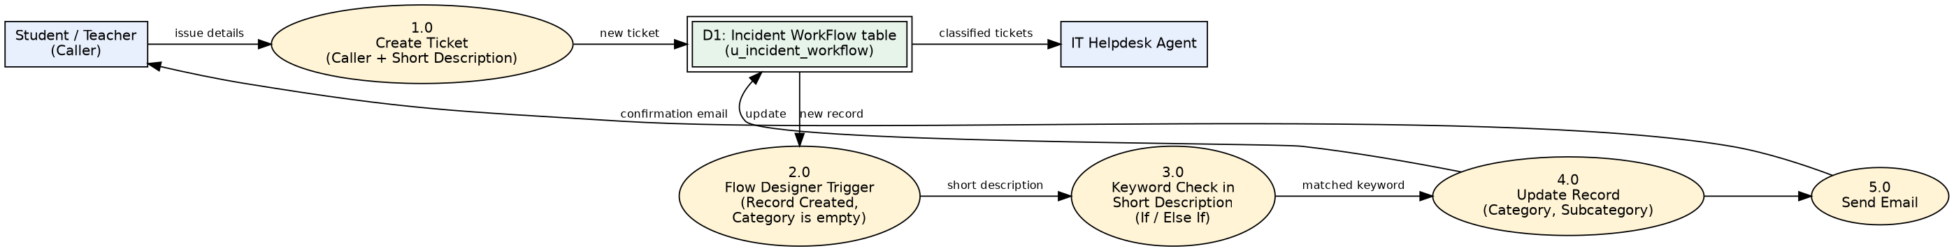
Figure 1: Data Flow Diagram

3.4 Technology Stack
Layer | Technology
User Interface | ServiceNow Platform UI – Incident WorkFlow form
Application Logic | ServiceNow Flow Designer: trigger, If / Else If conditions, Update Record, Send Email
Database | Custom table u_incident_workflow (auto-number INC prefix)
Infrastructure | ServiceNow cloud instance (Global application scope)
File Storage | Update set exported as XML file
External API / ML | Not used (no-code, keyword-based)

4. Project Design

4.1 Problem Solution Fit
Customer segments are students and teachers who raise IT tickets and the IT helpdesk staff who handle them. The root cause of the problem is manual classification of free-text tickets. The solution fits because the flow reads keywords at ticket creation, sets Category and Subcategory and emails the caller, without any code.

4.2 Proposed Solution
Parameter | Description
Problem Statement | Manual ticket classification in the school IT helpdesk is slow, error-prone and not scalable.
Idea / Solution | A Flow Designer flow classifies tickets by keywords in the Short Description and emails the caller.
Novelty | Fully no-code solution using Flow Designer and dependent choice fields.
Social Impact | Faster support for students and teachers and less manual work for IT staff.
Business Model | Internal school tool with no direct revenue; value is saved staff time. The update set can be shared with other institutions.
Scalability | New keywords and categories can be added without code.

4.3 Solution Architecture
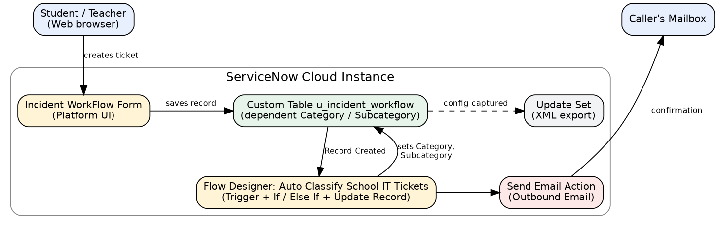
Figure 2: Solution Architecture

5. Project Planning & Scheduling

5.1 Project Planning
Sprint | Epic | User Story | Points | Priority
Sprint-1 | Ticket Creation | USN-1 Create ticket with Caller and Short Description | 2 | High
Sprint-1 | Ticket Creation | USN-2 No manual Category/Subcategory selection | 3 | High
Sprint-1 | Auto Classification | USN-4 Wi-Fi / Network classification | 3 | High
Sprint-1 | Auto Classification | USN-5 Projector, Password, Slow Computer classification | 3 | High
Sprint-1 | Configuration | USN-7 Dependent Category/Subcategory choices | 3 | Medium
Sprint-2 | Email Notification | USN-3 Confirmation email to caller | 2 | High
Sprint-2 | Ticket Management | USN-6 View and update classified tickets | 2 | Medium
Sprint-2 | Flow Maintenance | USN-8 Add new keywords to the flow | 3 | Medium
Sprint-2 | Deployment | USN-9 Update set export to XML | 1 | Low

Sprint-1 = 14 story points, Sprint-2 = 8 story points. Velocity = 22 / 2 = 11 story points per sprint.
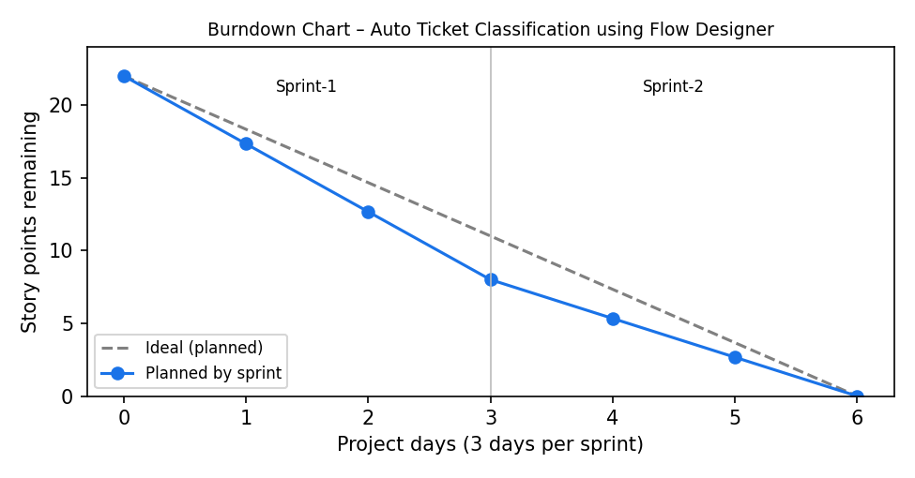
Figure 3: Burndown Chart (planned)

6. Functional and Performance Testing

6.1 Performance Testing
ID | Scenario | Expected Result | Result
FT-01 | Mandatory fields (Caller, Short description) | Fields marked mandatory | Pass
FT-02 | Category / Subcategory dependency | Only matching Subcategory is shown | Pass
FT-03 | Auto classification – Wi-Fi / Network | Network / Wi-Fi | Pass
FT-04 | Auto classification – Projector | Hardware / Projector | Pass
FT-05 | Email notification | Email created for caller | Pass
PT-01 | Classification after save and reload | Values filled automatically | Pass
PT-02 | Auto-number uniqueness | Unique INC numbers | Pass
PT-03 | Multiple tickets created together | Every ticket classified correctly | Not tested

User Acceptance Testing: 7 test cases were prepared. 4 passed, 3 are not yet tested (Forgot password, Slow computer and a no-keyword negative test), and no test failed.

7. Results

7.1 Output Screenshots
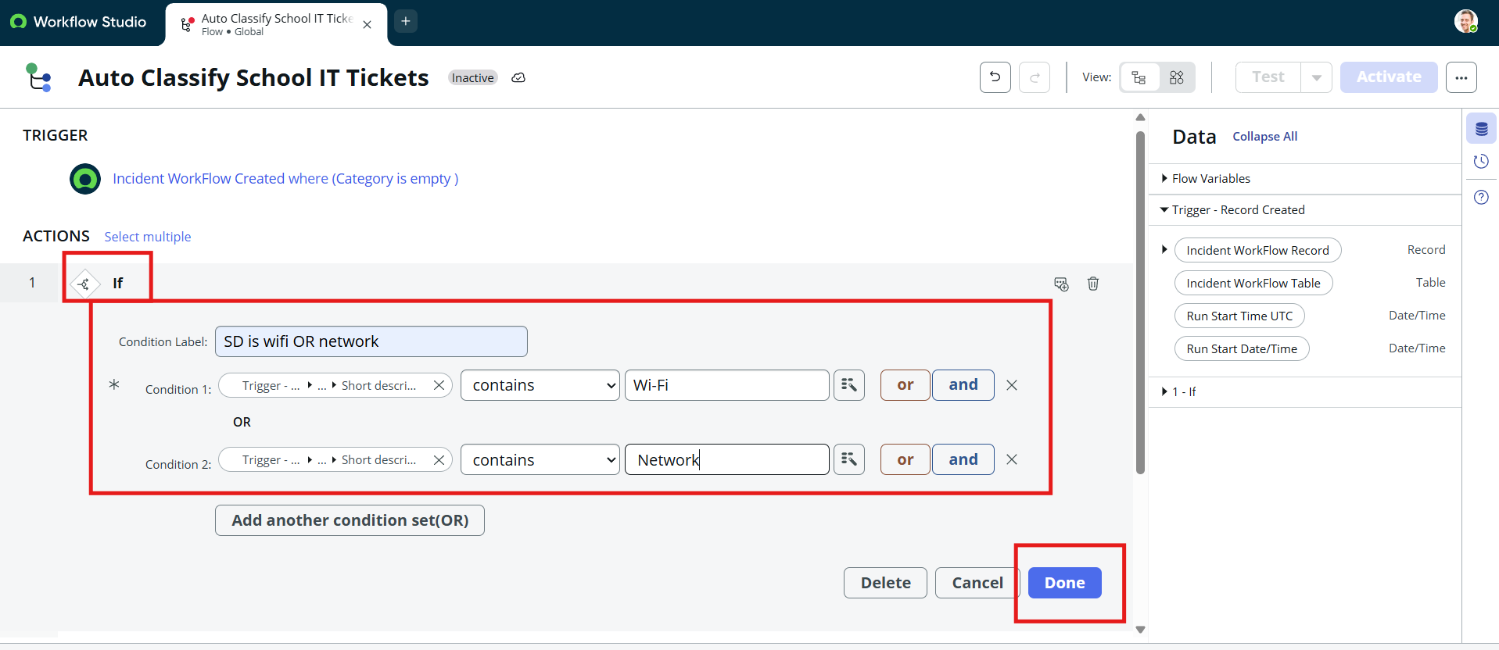
Figure 4: Flow trigger and Wi-Fi / Network condition
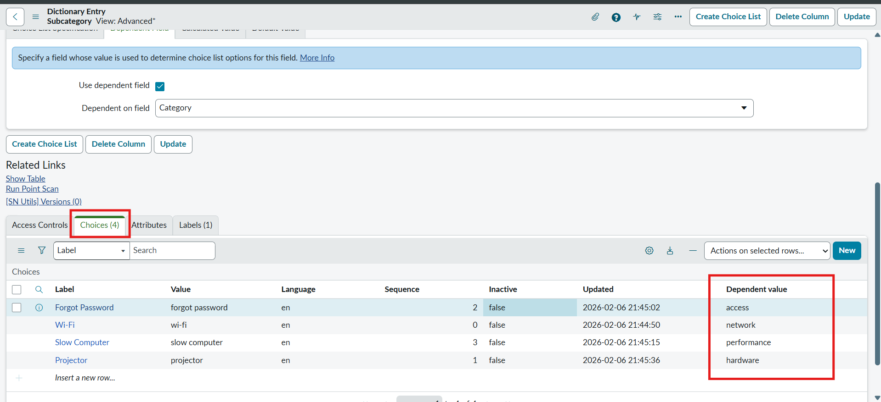
Figure 5: Dependent values for Subcategory choices
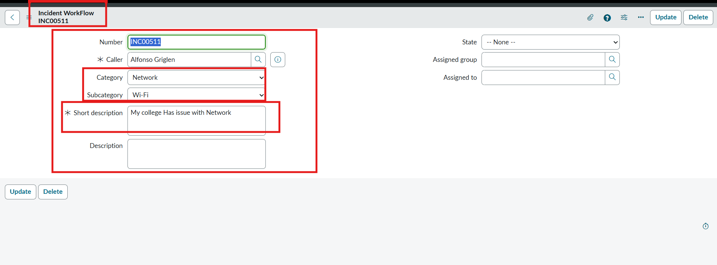
Figure 6: Test 1 – Network / Wi-Fi filled automatically (INC00511)
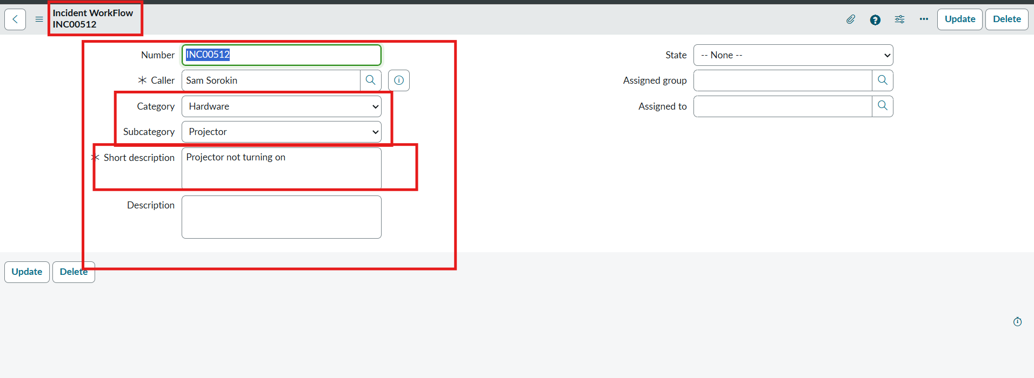
Figure 7: Test 2 – Hardware / Projector filled automatically (INC00512)
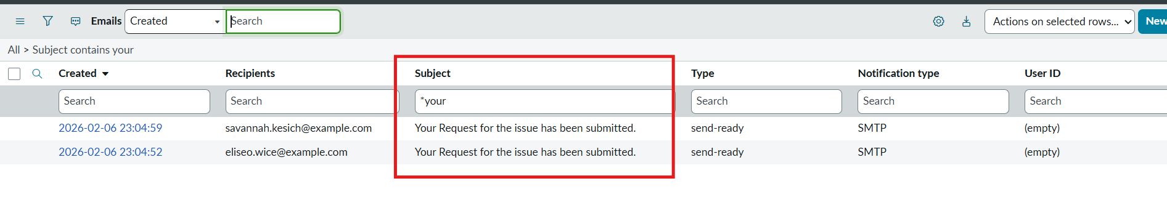
Figure 8: Confirmation emails in System Logs > Emails
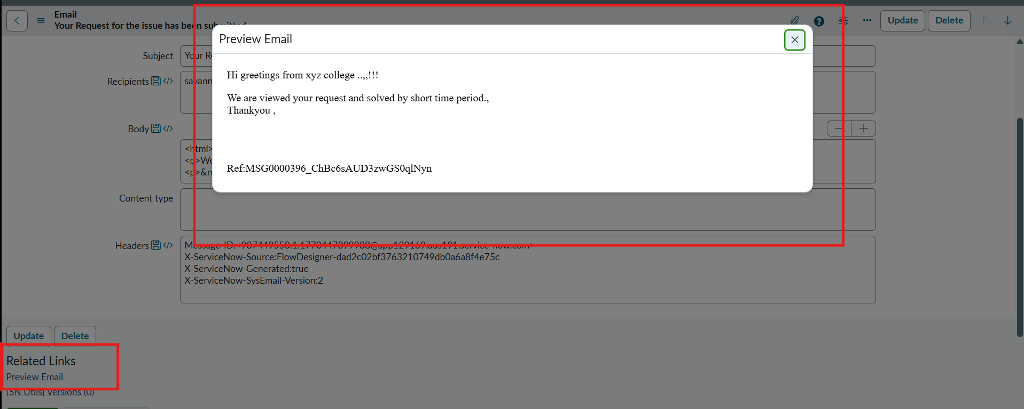
Figure 9: Preview of the confirmation email

8. Advantages & Disadvantages
Advantages
- No-code solution that is easy to maintain.
- Consistent classification and fewer human errors.
- Reduces manual effort for IT staff.
- Callers get an instant email confirmation.
- Update set makes it easy to move the solution to another instance.
Disadvantages
- Classification works only when the Short Description contains the configured keywords (for example Wi-Fi with hyphen, Forgot password); otherwise Category stays empty.
- Only four issue types are covered at present.
- Email is sent only if the caller has an email address.
- Tickets are not assigned to a group or agent automatically.

9. Conclusion
The Auto Ticket Classification using Flow Designer project delivers an end-to-end automation solution for a school IT helpdesk. The objective of reducing manual effort in ticket categorization and improving response efficiency has been achieved.
Through requirement analysis, backend configuration and no-code automation, the system classifies IT tickets from the short description. Dependent choice fields keep the data accurate, and automated emails acknowledge each ticket. The design suits small and medium environments such as educational institutions.

10. Future Scope
- Assignment automation (auto-assign group and agent).
- SLA tracking and dashboards.
- Predictive intelligence for classification.
- More keywords and categories, such as printer or email issues.

11. Appendix
Source Code: No code was written. The solution uses Flow Designer; the configuration is available in the Project Update Set XML.
Dataset Link: Not applicable.
GitHub Link: https://github.com/rohini-r-2006/Auto-ticket-Classification-using-flow-designer-.git
Project Demo Link:

